
Applied Science Private University
Faculty of Information Technology

Graduation Project Report

TITLE
SECUREWATCH: It Wasn’t Me.

Prepared by:
Rose Absah 202210076
Shada Haitham 202220697
Jaser Sinjalawi 202420471

Supervised by:
Supervisor’s Name

June 2026

Copyright © 2023-2024 Applied Science Private University. All rights are reserved

We certify that the work and ideas presented in this project is our own unless referenced.

Name and Signature:………………………………….…………………. Date: …………………
Name and Signature:………………………………….…………………. Date: …………………
Name and Signature:………………………………….…………………. Date: …………………
Name and Signature:………………………………….…………………. Date: …………………

Contents
List of Figures iii
List of Tables iv
List of Symbols v
Abstract vi
Chapter 1: Introduction 7
1.1 Description of the current situation and opportunity 7
1.2 Related work 7
1.3 Problem statement (limitation of current systems) 7
1.4 Problem solution 7
1.5 Project objectives 7
1.6 Technology and tools used 7
1.7 Project Plan (Gantt chart & PERT chart) 7
Chapter 2: Requirements and Analysis 8
2.1 Software Process Model with explanation 8
2.2 System scope with explanation 8
2.3 Functional Requirements & Non-Functional Requirements 8
2.4 Use Case Diagram with Use Cases descriptions 8
2.5 Activity Diagram for some use case scanrios 8
Chapter 3: Design 9
3.1 Sequence Diagrams for some use case scenarios 9
3.2 Detailed Class Diagram 9
3.3 Database ER Diagram (if applicable) 9
Chapter 4: System Implementation 10
4.1 Main System Screenshots 10
4.2 Important code fragments 10
4.3 List of Non-Implemented requirements and reasons 10
Chapter 5: System Evaluation 11
5.1 System Testing (some test cases) 11
5.2 System Evaluation 11
Chapter 6: Conclusion & Future Work 12
6.1 Conclusion 12
6.2 Future work 12
References 13
Appendix 14

List of Figures

Figure 1: Use-Case Diagram .

List of Tables

Table 1: Code conversion table 7

List of Symbols

Symbols | Meaning
AD
DC
API
VM
OU
GP
SIEM

Abstract
SecureWatch is a cloud access monitoring and protection system for Microsoft OneDrive. It continuously collects audit and sign-in logs via Microsoft Graph API, Microsoft Entra and ADDC builds user behavior baselines, and applies rule-based detection to identify suspicious activities such as failed logins, mass downloads, and privilege escalation. A web dashboard visualizes alerts and risk scores, enabling administrators to respond quickly. SecureWatch addresses insider threats and compromised accounts, filling gaps left by traditional perimeter-based security tools.

________________________________________

The rising risk of insider threats and credential theft in cloud storage platforms like Microsoft OneDrive highlights the need for affordable, intelligent monitoring solutions. SecureWatch is a lightweight, rule-based monitoring system that integrates with Microsoft Entra ID and Graph API to collect audit and sign-in logs. It builds user baselines, detects anomalies such as failed logins, suspicious IPs, and mass downloads, and provides real-time alerts via a dashboard and email summaries. SecureWatch was tested against simulated attack scenarios, demonstrating effective detection and reduced administrative overhead, making it suitable for academic and SME environments.

Chapter 1: Introduction
In today’s digital era, cloud storage platforms such as Microsoft OneDrive have become essential for organizations and individuals, offering flexible storage, seamless collaboration, and remote accessibility. Despite these advantages, cloud environments remain vulnerable to insider threats and credential theft. Attackers who gain valid user credentials through phishing, malware, or insider misuse can bypass traditional perimeter defenses, making their actions appear legitimate. This reality underscores the importance of continuous monitoring and intelligent detection systems that go beyond password authentication and static access controls.
The project focuses on the implementation and configuration of SecureWatch, a lightweight monitoring solution designed specifically for Microsoft OneDrive. SecureWatch leverages Microsoft Entra ID audit and sign-in logs, accessed through the Microsoft Graph API, to provide real-time visibility into user activity. By analyzing these logs, the system can detect anomalies such as failed login attempts, suspicious IP addresses, mass file downloads, and privilege escalation. SecureWatch introduces a rule-based detection engine, risk scoring, and a web-based dashboard to deliver actionable insights and timely alerts. To reduce administrative burden, the system also incorporates automated email summaries, enabling administrators to stay informed without constant dashboard monitoring.
SecureWatch is intended to serve as an affordable and practical solution for academic environments, small and medium-sized enterprises, and organizations seeking to strengthen their cloud security posture without the complexity or cost of enterprise SIEM platforms. The system was tested against simulated attack scenarios, including brute-force login attempts and unauthorized access patterns, to validate its effectiveness. By combining log analysis, anomaly detection, and automated reporting, SecureWatch demonstrates that advanced cloud monitoring can be achieved with minimal resources, aligning with industry practices while remaining accessible to resource-constrained environments.

Description of the current situation and opportunity
Cloud storage platforms such as Microsoft OneDrive have become central to modern organizations, providing seamless collaboration, remote access, and centralized data management. However, these advantages come with significant risks. Insider threats and credential theft remain critical challenges, as attackers who obtain valid user credentials through phishing, brute-force attempts, or insider misuse can bypass traditional perimeter defenses. Once authenticated, their actions appear legitimate, making detection difficult.
Although Microsoft Entra ID generates comprehensive audit and sign-in logs that record authentication attempts, file access, and administrative changes, many institutions—particularly small and medium-sized enterprises (SMEs) and academic environments—lack affordable tools to analyze these logs effectively in real time. Enterprise-grade SIEM platforms offer advanced monitoring but are often prohibitively expensive and complex to deploy, leaving resource-constrained organizations exposed to data exfiltration, unauthorized access, and compliance risks.
This gap presents a clear opportunity: the development of a lightweight, rule-based monitoring system that leverages existing audit and sign-in logs to detect suspicious activity in OneDrive environments. By emphasizing affordability, simplicity, and real-time detection, such a solution can bridge the divide between costly enterprise SIEM platforms and the practical needs of smaller organizations. SecureWatch was designed to fulfill this role, providing continuous monitoring, anomaly detection, and automated reporting without the overhead of complex commercial systems.

Related work
A variety of commercial and open-source platforms exist to provide visibility into user activity and detect suspicious behavior in cloud and enterprise environments. Each solution offers unique strengths but also presents limitations that make them less suitable for small organizations or academic contexts.
- Splunk Enterprise Security :is a leading SIEM platform that provides real-time monitoring, customizable dashboards, and advanced analytics. It is widely adopted in large enterprises due to its scalability and integration capabilities. However, Splunk requires significant expertise to configure and maintain, and its licensing costs are prohibitive for smaller organizations.
- IBM QRadar :offers powerful correlation and threat detection features, with strong compliance reporting. It is effective in large SOC environments but suffers from high infrastructure requirements and complex pricing models. For SMEs, QRadar’s cost and complexity often outweigh its benefits.
- LogRhythm: provides endpoint monitoring and incident detection based on indicators of compromise (IOCs). While effective against known threats, its reliance on static detection rules makes it weaker against novel or advanced attack techniques.
- Wazuh:, an open-source SIEM platform, has gained popularity for its modularity and cost-effectiveness. It supports log collection, rule-based detection, and compliance mapping, making it suitable for SMEs and academic labs. However, Wazuh requires technical expertise to configure detection rules and maintain dashboards, which can be challenging for non-specialist teams.
- Cloud Access Security Brokers (CASBs): extend visibility into cloud applications, offering data loss prevention and access control. While effective in enterprise environments, CASBs are subscription-based and require integration with multiple cloud services, limiting their accessibility for smaller organizations.
In contrast to these solutions, SecureWatch focuses specifically on Microsoft OneDrive environments. By leveraging Microsoft Entra ID audit and sign-in logs through the Graph API, SecureWatch provides targeted monitoring without the overhead of enterprise SIEM platforms. Its lightweight, rule-based detection engine and automated reporting are designed to reduce complexity and cost, making it practical for SMEs, universities, and resource-constrained environments.

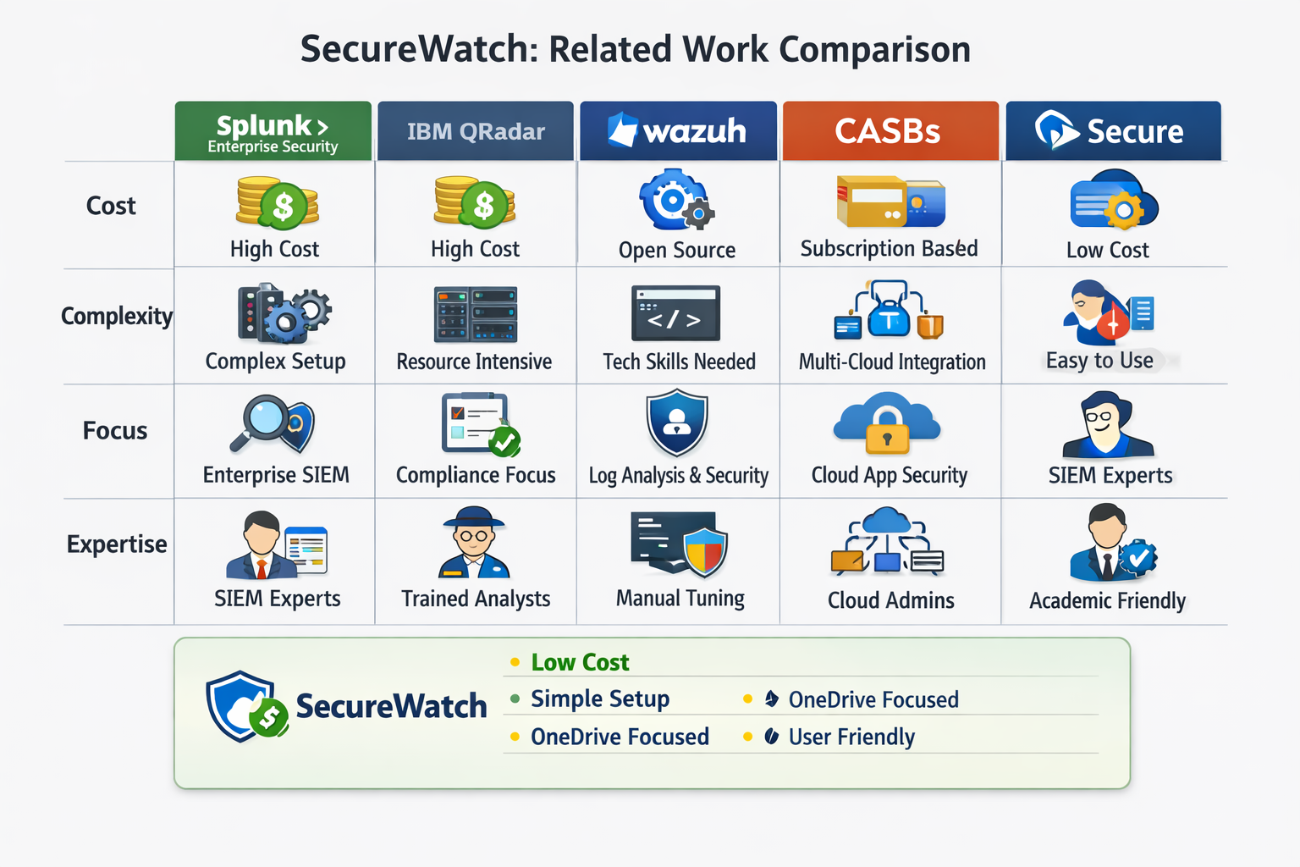

Problem statement (limitation of current systems)
Although cloud storage platforms such as Microsoft OneDrive provide encryption, access controls, and audit logging, these measures alone are insufficient to protect against modern threats. Attackers who gain valid credentials through phishing, brute-force attempts, or insider misuse can operate within the system as legitimate users, bypassing traditional defenses. Detecting such activity requires continuous monitoring and intelligent analysis of audit and sign-in logs.
Existing enterprise SIEM solutions, while powerful, are often prohibitively expensive and complex to deploy. They demand specialized expertise, extensive infrastructure, and ongoing maintenance, making them impractical for small and medium-sized enterprises (SMEs) and academic institutions. Furthermore, many SIEM platforms rely heavily on static detection rules or indicators of compromise (IOCs). This approach struggles against evolving attack techniques, leading to gaps in detection and reliance on outdated logic.
Another limitation is alert fatigue. Traditional systems generate large volumes of alerts, requiring administrators to manually review dashboards. This increases response times and raises the risk of missing critical incidents. Without summarized reporting or prioritization, administrators face significant challenges in maintaining situational awareness.
Finally, many organizations lack visibility into their overall security posture and compliance alignment. While logs may capture events, they often fail to provide insights into misconfigurations, policy gaps, or adherence to standards such as NIST, GDPR, or HIPAA. This leaves organizations exposed to regulatory risks and unnoticed vulnerabilities.
These limitations highlight the need for a lightweight, affordable, and adaptive monitoring solution that can provide real-time detection, reduce administrative burden, and improve visibility into both user activity and compliance posture. SecureWatch was designed to address these gaps.

Problem solution
To address the limitations of existing cloud monitoring systems, SecureWatch introduces a lightweight, affordable, and adaptive solution specifically tailored for Microsoft OneDrive environments. The system leverages Microsoft Entra ID audit and sign-in logs, accessed through the Microsoft Graph API, to provide continuous visibility into user activity. By focusing on simplicity and real-time detection, SecureWatch bridges the gap between costly enterprise SIEM platforms and the practical needs of smaller organizations and academic institutions.
- Cost-Effectiveness: SecureWatch eliminates the need for expensive licensing fees by relying on open APIs and lightweight components. This makes it accessible to SMEs, universities, and resource-constrained environments.
- Customizability: Administrators can define rule-based detection logic tailored to their environment. SecureWatch supports thresholds for failed logins, suspicious IP addresses, after-hours access, and mass downloads, ensuring flexibility without requiring complex configurations.
- Scalability: The modular architecture allows SecureWatch to scale from small deployments to larger environments. Logs can be stored in SQLite for lightweight use or integrated with enterprise databases for higher capacity.
- Real-Time Monitoring: SecureWatch continuously collects and analyzes audit and sign-in logs, enabling immediate detection of anomalies. Alerts are prioritized using a risk scoring mechanism (Low, Medium, High, Critical), ensuring administrators can focus on the most urgent threats.
- Automated Reporting: To reduce alert fatigue, SecureWatch introduces an email summarization mechanism. Periodic summaries provide administrators with concise overviews of system activity and alert severity, minimizing the need for constant dashboard monitoring.
- Compliance Visibility: SecureWatch aligns with NIST SP 800-92 guidelines for log management, supporting secure storage, integrity protection, and forensic readiness. This enhances visibility into organizational security posture and regulatory compliance.
By combining log analysis, anomaly detection, risk scoring, and automated reporting, SecureWatch provides a practical solution that strengthens cloud security without the complexity of enterprise SIEM platforms.

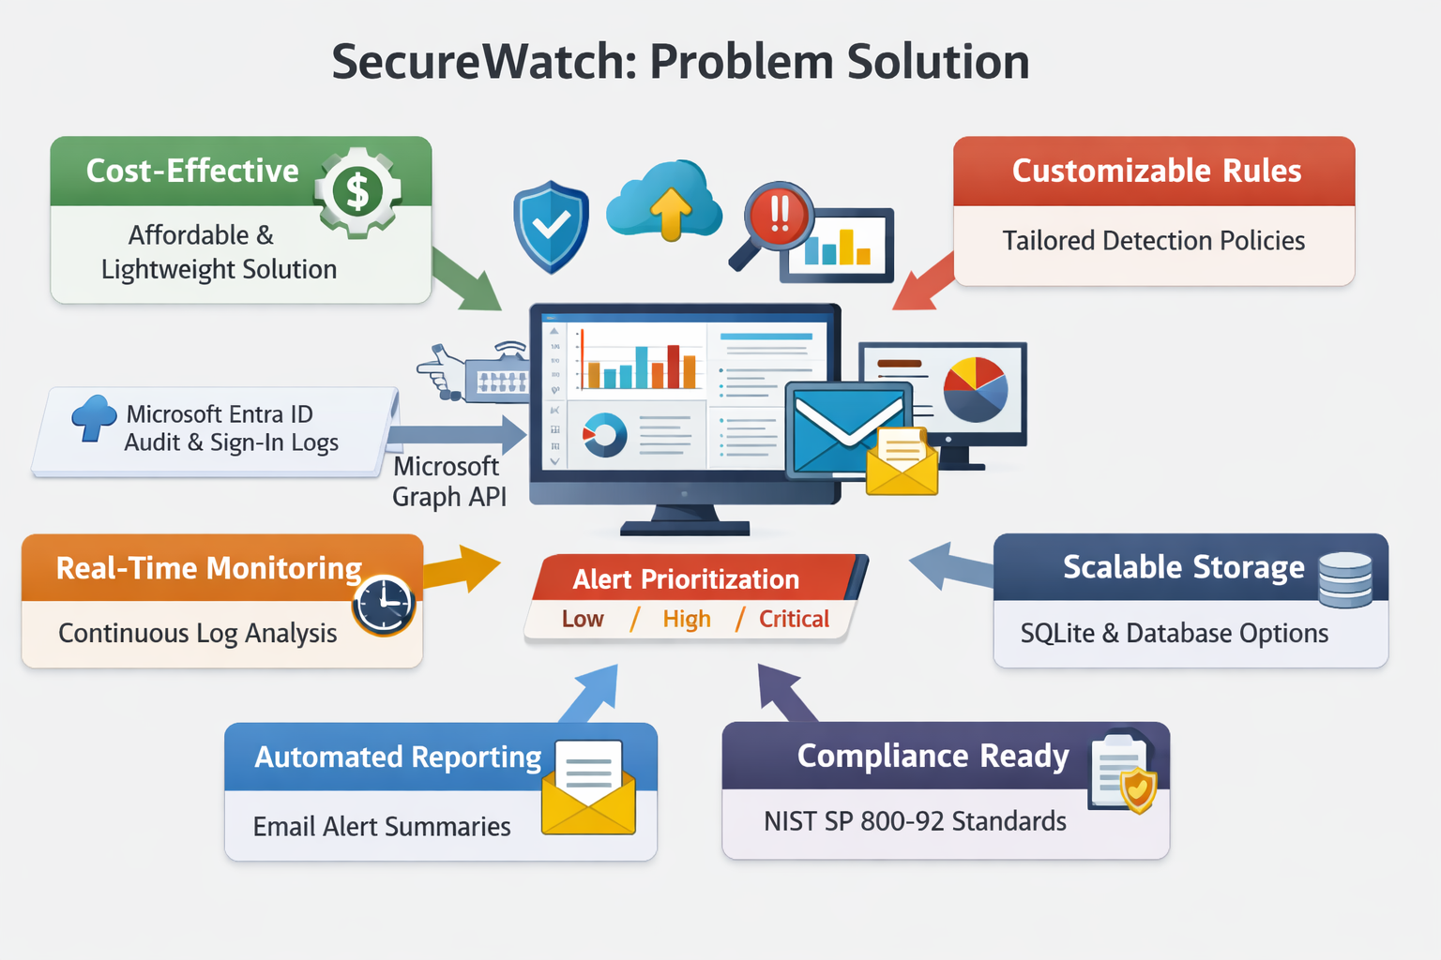

Project objectives
The primary objective of this project is to design and implement a lightweight monitoring system capable of detecting suspicious activity within Microsoft OneDrive environments by analyzing audit and sign-in logs from Microsoft Entra ID. SecureWatch aims to enhance visibility, reduce administrative workload, and strengthen cloud security for small and medium-sized organizations as well as academic institutions.
The specific objectives are as follows:
- Deploy and Configure SecureWatch: Install and configure the SecureWatch environment using Microsoft Graph API integration to enable secure access to audit and sign-in logs.
- Collect and Store Logs: Retrieve and store OneDrive audit and sign-in logs in a structured database for continuous monitoring and historical analysis.
- Detect Anomalies: Develop rule-based detection logic to identify suspicious patterns such as failed login attempts, unusual IP addresses, after-hours access, and mass downloads.
- Alert and Prioritize: Implement a risk-scoring mechanism to classify alerts by severity (Low, Medium, High, Critical) and support timely incident response.
- Visualize Threats: Design a web-based dashboard to display real-time alerts, user risk profiles, and system activity trends for intuitive analysis.
- Automate Reporting: Create an automated email summarization system that periodically delivers concise reports of detected events and system health to reduce alert fatigue.
- Validate Detection Accuracy: Conduct controlled simulations of attack scenarios such as brute-force login attempts and unauthorized access to evaluate system performance and detection reliability.
- Ensure Compliance and Forensic Readiness: Align log management and storage practices with NIST SP 800-92 guidelines to support secure retention, integrity verification, and audit readiness.

Technology and tools used

The SecureWatch system integrates several technologies to achieve efficient log collection, anomaly detection, and real-time alerting within Microsoft OneDrive environments. Each component was selected for its reliability, scalability, and compatibility with modern infrastructures.
- Microsoft Graph API
Serves as the primary interface for accessing Microsoft Entra ID audit and sign-in logs. It enables SecureWatch to retrieve authentication events, user actions, and administrative changes directly from the cloud environment.
- Microsoft Entra ID (Azure Active Directory)
Provides identity and access management capabilities, generating detailed logs of user sign-ins, failed authentication attempts, and privilege modifications. These logs form the foundation of SecureWatch’s detection engine.

- Active Directory (Windows Server)
SecureWatch also integrates with on-premises Active Directory (AD) running on Windows Server. AD provides centralized authentication and authorization for users and devices. By correlating AD logs with Entra ID audit data, SecureWatch enhances visibility across hybrid environments, detecting anomalies such as unauthorized domain logins, privilege escalation, and suspicious group membership changes.
- Python Programming Language
Used for the core modules of SecureWatch, including:
- MSAL (Microsoft Authentication Library) for secure API authentication.
- SQLite for lightweight database storage.
- smtplib for automated email alerting.
- SQLite Database
Provides lightweight, file-based storage for audit and sign-in logs, supporting fast queries and efficient indexing.
- Web Dashboard (HTML, CSS, JavaScript, Chart.js,flask)
Visualizes system activity and alert severity. Chart.js enables dynamic graphs and charts that display login trends, risk scores, and anomaly distributions

- Virtualization Environment (VMware / Docker)
SecureWatch was deployed and tested in a virtualized environment using VMware Workstation and Docker containers, ensuring isolation and reproducibility during attack simulations.

- Compliance Frameworks
SecureWatch follows NIST SP 800-92 guidelines for log management, ensuring secure retention, integrity protection, and forensic readiness.

Project Plan (Gantt chart, PERT chart)

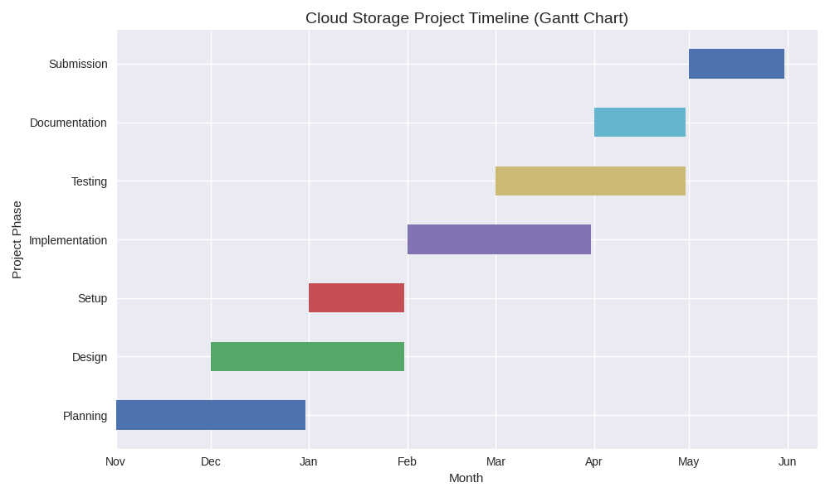
Chapter 2: Requirements and Analysis

Software Process Model

The development of SecureWatch adopts an Iterative Development approach based on Agile principles. This model emphasizes repeated cycles of planning, implementation, and testing, allowing continuous improvement and adaptability throughout the project lifecycle. Each iteration delivers a functional increment of the system, enabling early validation and refinement without restarting the process.
This methodology is particularly suitable for security monitoring systems, which require frequent updates to detection rules, reporting mechanisms, and compliance features in response to evolving threats. By applying iterative cycles, SecureWatch ensures flexibility, rapid feedback integration, and resilience against changing requirements.
- Iterative Development Lifecycle Phases
- Iteration Planning
  - Define project goals and objectives.
  - Select system architecture (Microsoft Graph API + Active Directory integration).
  - Plan automated email reporting frequency and content.
  - Determine scope for rule-based anomaly detection.
- Design
  - Identify system architecture and modules (log collection, detection, dashboard, reporting).
  - Design use cases for hybrid environments (cloud + Windows Server AD).
  - Specify database schema for log storage and retrieval.
- Implementation
  - Develop Python modules for log collection, detection, and reporting.
  - Configure SQLite database and dashboard visualization.
  - Integrate email summarization scripts.
- Testing
  - Validate detection rules with simulated attack scenarios (brute-force, mass downloads, privilege escalation).
  - Assess dashboard usability and reporting accuracy.
  - Refine rules and thresholds based on feedback.
- Deployment & Feedback
  - Deploy SecureWatch in a controlled environment.
  - Collect feedback from administrators and refine system features.
  - Prepare for scaling to larger environments.

In table layout:

Stage | Description | Icon Suggestion
Planning | Define project goals, select architecture (Graph API + AD), and set reporting scope. | Calendar or checklist
Design | Identify modules (log collection, detection, dashboard, reporting) and database schema. | Blueprint or gear
Implementation | Develop Python modules, configure SQLite, and integrate email scripts. | Code brackets
Testing | Simulate attack scenarios, validate detection accuracy, and refine rules. | Magnifying glass or bug
Deployment & Feedback | Deploy SecureWatch, gather feedback, and prepare for scaling. | Cloud or feedback icon

Diagram
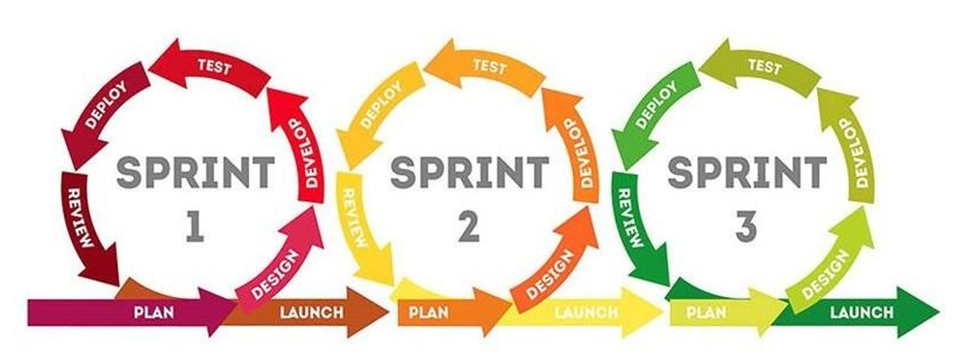
.

System scope with explanation
The scope of SecureWatch defines the boundaries and capabilities of the system, ensuring clarity in its objectives and limitations. SecureWatch is designed as a lightweight monitoring solution for Microsoft OneDrive environments, integrating both Microsoft Entra ID and Active Directory (Windows Server) to provide hybrid visibility.
- In-Scope Features
- Log Collection: Retrieve audit and sign-in logs from Microsoft Graph API and Active Directory.
- Anomaly Detection: Identify suspicious activities such as failed logins, unusual IP addresses, mass downloads, and privilege escalations.
- Alerting System: Generate alerts with severity levels (Low, Medium, High, Critical).
- Dashboard Visualization: Provide administrators with real-time insights into user activity, risk scores, and system health.
- Email Summarization: Automate periodic reporting to reduce alert fatigue.
- Compliance Alignment: Follow NIST SP 800-92 guidelines for secure log management and forensic readiness.
- Out-of-Scope Features
- Monitoring of non-Microsoft cloud services (e.g., Google Drive, Dropbox).
- Advanced machine learning-based anomaly detection (future enhancement).
- Large-scale enterprise SIEM functionalities such as correlation across multiple platforms.
- Integration with third-party CASBs or external threat intelligence feeds.
- System Boundaries
- SecureWatch operates within Microsoft OneDrive and Entra ID environments, supplemented by Windows Server AD logs.
- It does not replace enterprise SIEM platforms but provides a focused, cost-effective solution for academic and small-to-medium organizations.
- The system is limited to environments with stable internet connectivity and synchronized timestamps.

Functional Requirements & Non-Functional Requirements

The functional requirements define the essential operations that SecureWatch must perform to achieve its objectives. Each requirement is uniquely identified for traceability during design, implementation, and testing.

ID | Requirement | Description
FR-01 | Log Collection | Retrieve audit and sign-in logs from Microsoft Graph API and Windows Server Active Directory.
FR-02 | Log Storage | Store collected logs securely in SQLite for efficient querying and reporting.
FR-03 | Rule-Based Detection | Apply predefined rules to identify anomalies such as failed logins, privilege escalation, and mass downloads.
FR-04 | Alert Generation | Trigger alerts with severity levels (Low, Medium, High, Critical) based on detection outcomes.
FR-05 | Dashboard Visualization | Provide administrators with a web-based dashboard showing alerts, risk scores, and activity trends.
FR-06 | Email Summarization | Send automated periodic reports summarizing detected events and system health.
FR-07 | User Authentication | Ensure secure login for administrators to access the dashboard and manage detection rules.
FR-08 | Hybrid Integration | Correlate logs from both cloud (Entra ID) and on-premises (Active Directory) environments for unified monitoring.
FR-09 | Compliance Support | Align log management practices with NIST SP 800-92 guidelines for forensic readiness.

Nonfunctional requirements

Category | Requirement | Description
Performance | Real-time log processing | SecureWatch must process and analyze logs within seconds of retrieval to ensure timely detection of anomalies.
Reliability | Continuous operation | The system should run 24/7 with minimal downtime, ensuring uninterrupted monitoring.
Security | Data protection | All logs and credentials must be encrypted, with strict access controls to prevent unauthorized use.
Usability | Intuitive interface | The dashboard must be user-friendly, enabling administrators with limited technical expertise to navigate easily.
Scalability | Modular design | SecureWatch should support expansion to other cloud services and larger environments without major redesign.
Maintainability | Rule updates | Detection rules must be easily editable and extendable to adapt to new threats.
Compliance | Standards alignment | SecureWatch must follow NIST SP 800-92 guidelines for log management and forensic readiness.
Portability | Virtualization support | The system should run smoothly in VMware or Docker environments for testing and deployment flexibility.

2. Use Case Diagram with Use Cases descriptions
Use case diagrams model the functionality of a system using actors and use cases. Use cases are a set of actions, services, and functions that the system needs to perform. It demonstrates the different ways that a user might interact with a system.

3. Activity Diagram
Activity diagram is basically a flowchart to represent the flow from one activity to another activity. The activity can be described as an operation of the system. The control flow is drawn from one operation to another.

Chapter 3: Design

Sequence Diagrams
A sequence diagram is a type of interaction diagram because it describes how—and in what order—a group of objects works together. These diagrams are used by software developers and business professionals to understand requirements for a new system or to document an existing process.

Class Diagram
In software engineering, a class diagram in the Unified Modeling Language (UML) is a type of static structure diagram that describes the structure of a system by showing the system's classes, their attributes, operations (or methods), and the relationships among objects.

Database ER Diagram
Entity relationship diagram displays the relationships of entity set stored in a database.

Chapter 4: System Implementation

Main System Screenshots
Show screenshots of your system.

Important code fragments
Show important codes of your implemented system.

List of Non-Implemented requirements and reasons

List of not implemented requirements and explain reasons.

Chapter 5: System Evaluation

System Testing
The purpose of this test is to evaluate the system's compliance with the specified requirements. Test Cases Using Black Box Testing methods.

System Evaluation
System evaluation is the process of assessing the performance of a complete system to discover how it is likely to perform in live market conditions. It may include evaluation tables and graphs.

Chapter 6: Conclusion & Future Work
It should drive the reader to see that you accomplish your objectives, and you should state any further work recommendations.

Conclusion
A conclusion summarizes the report as a whole, drawing inferences from the entire process about what has been found, or decided, and the impact of those findings or decisions.

Future work
Recommendations on how you might want to improve the work in future.

References
Cite sources you used in your report.

Appendix
Any additional information or data that supports or extends the main document or report.

